class Solution:

def mySqrt(self, x):

low=0

high=x

if x==0:

return 0

if x==1:

return 1

while(low<high):

mid=(low+high)//2

sqrtt=mid*mid

if sqrtt==x:

return mid

if sqrtt>x:

high=mid-1

if sqrtt<x:

low=mid+1

if low*low>x:

return low-1

else:

return low

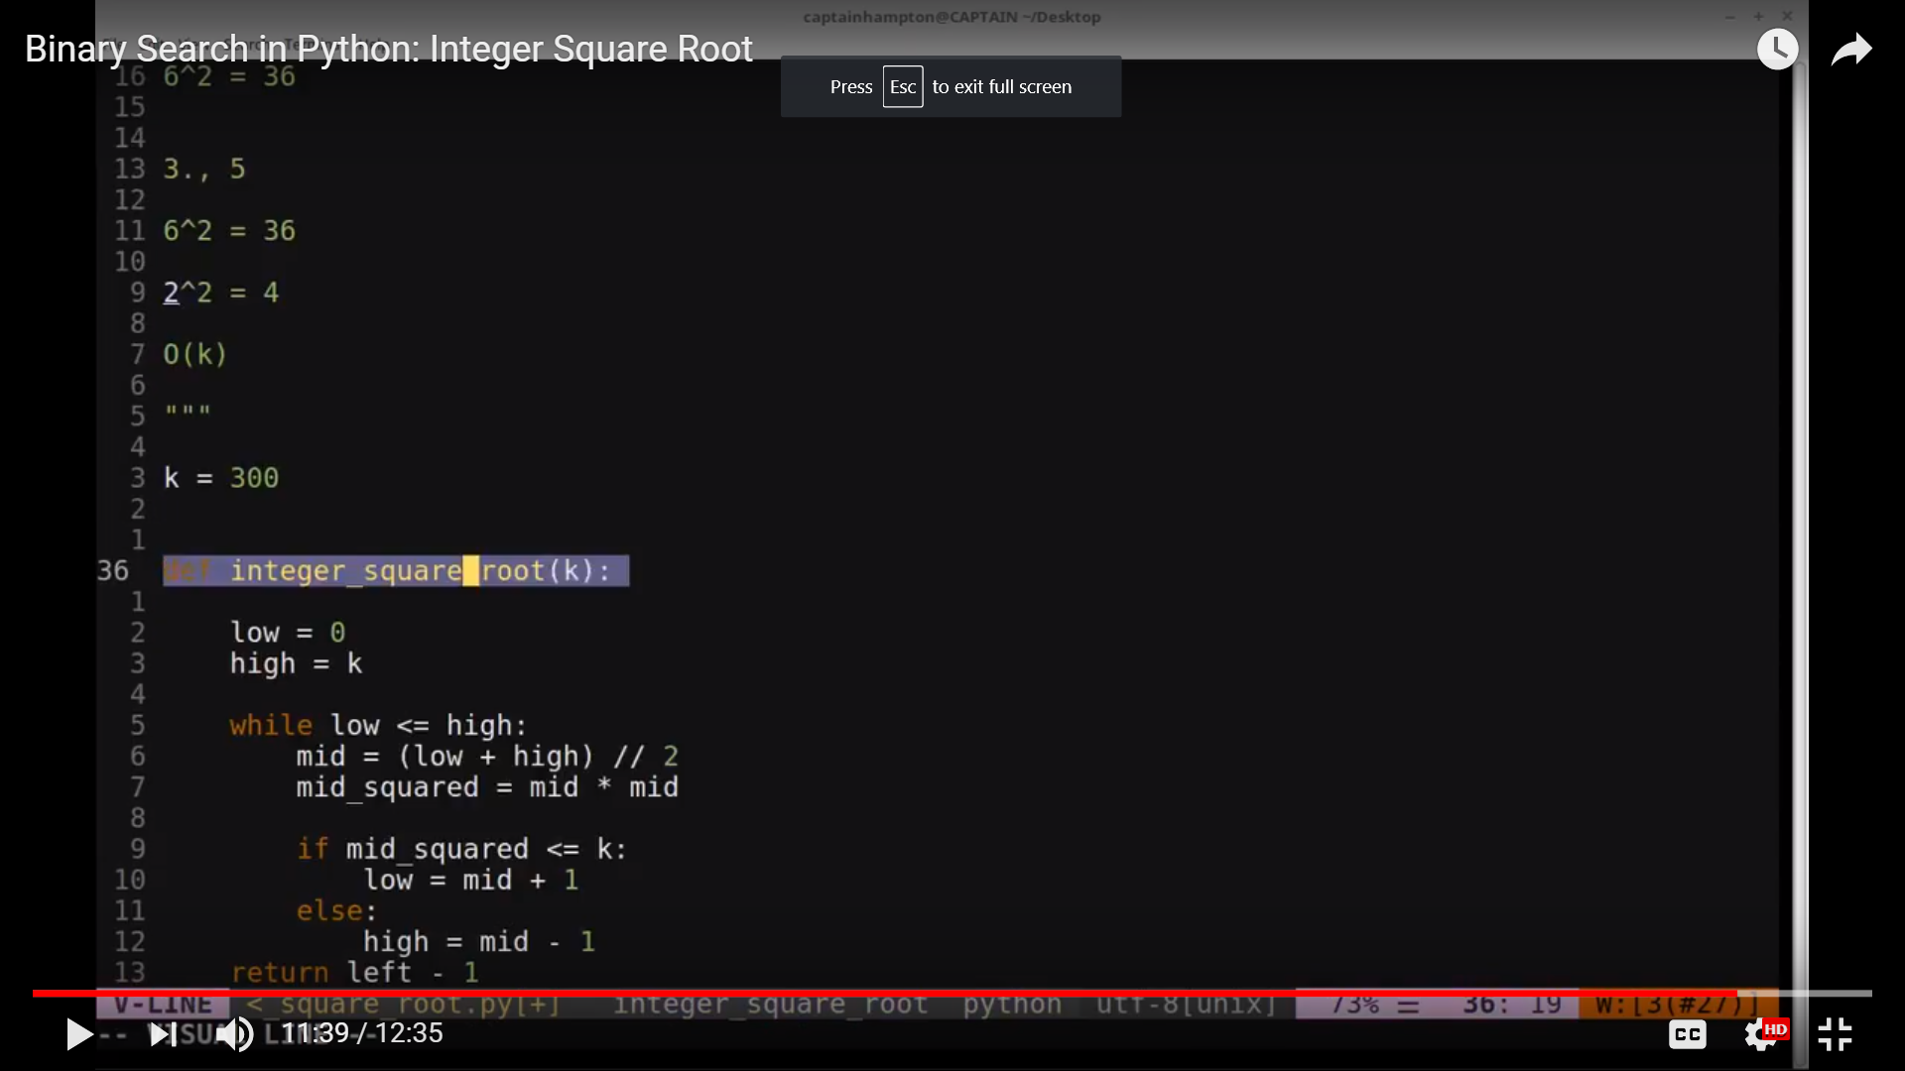

<https://www.youtube.com/watch?v=plbSgfLCt74>

**class** **Solution**(object):

**def** **mySqrt**(self, x):

"""

:type x: int

:rtype: int

"""

**if** x <= 1:

**return** x

l, h = 1, x

**while** l <= h:

m = l + (h - l)/2

**if** m*m == x:

**return** m

**elif** m*m < x:

l = m + 1

**elif** m*m > x:

h = m - 1

**return** h